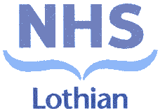
THIS PHARMACY IS CLOSED TODAY

YOUR NEAREST PHARMACY IS

OPENING HOURS

